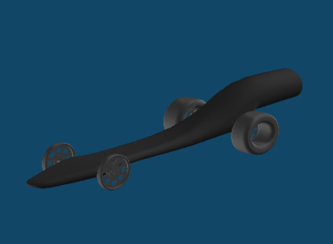 Design development

This is my first design it was in spec light and fast. 1.3367 But not in spec, it looks better than some of my most designs. And the axle hole was to thin. And then I made it thicker.

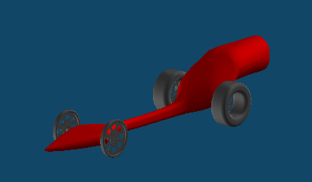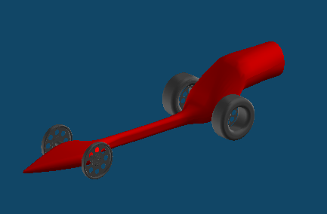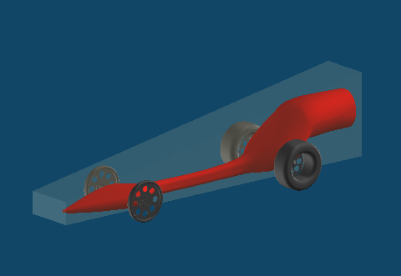

This is my 15th design it was in spec and fast with a time of 1.31011 I stayed with the same design and tried to take away the friction where it goes up and around the co2 cartridge.

This is my 10th design it was in spec and fast but I could not make it lighter because it would go out of spec. and I changed the colour to red and added more on the back because I could see the co2 cartridge and it fell out of spec, and its time was 1.3301

This is my 18th and final design I tried to make it faster by shaving wood off every time but I could not get it faster so that is my final design.